|  |  |
| --- | --- |
|  | **Faculty of Environment and Technology**  **Academic Year: 2022/2023**  **End of Teaching Block or Date: 2** |

**Module Leader: Mokhtar Nibouche**

**Module Code UFMFMT-30-2**

**Module Title: Signals and Systems**

**Examination Duration: 120 minutes**

**ONLINE EXAM**

**Instructions to Students:**

* There are FOUR (04) questions in the exam paper. **Answer all questions**.
* Each question carries 25 marks.
* As is usual for an exam, for this assessment you are not expected to include full referencing, but are encouraged to cite the sources of key theories, models, case studies, statutes etc.
* This is an individual assessment: do not copy and paste work from any other source or work with any other person during this exam. Text-matching software will be used on all submissions.

**Formatting**

* Please use **.pdf** file format when submitting. We cannot ensure that other formats are compatible with markers’ software and cannot guarantee to mark incorrect formats.
* **Please include the module name and number and your student number (not your name).** Please indicate clearly which questions you are answering.

**Instructions for submission**

You must submit your assignment before the stated deadline by electronic submission through Blackboard.

* Multiple submissions can be made to the portal, but only the final one will be accepted. Please save your work frequently.
* **It is your responsibility to submit exam in a format stipulated above**

Your marks may be affected if your tutor cannot open or properly view your submission.

* **Do not leave submission to the very last minute.** Always allow time in case of technical issues.
* The date and time of your submission is taken from the Blackboard server and is recorded when your submission is complete, not when you click Submit.
* **It is essential that you check that you have submitted the correct file(s),** and that each complete file was received. Submission receipts are accessed from the Coursework tab.

**There is no late submission permitted on this timed assessment.**

**QUESTION 1 [25 marks]**

1. Using the phasor graphical method, determine Y(t) = Y1(t) + Y2(t), where

Y1(t) = 5sin(5t + 50o) and Y2(t) = 3cos(5t)i

**[8 marks]**

1. Determine the transfer function of the electrical circuit of Figure Q1 and then put it under the normalised form:



**[8 marks]**

Calculate the numerical values of the static gain, **K**, the natural frequency, , and the damping factor, .

**[3 marks]**

|  |  |
| --- | --- |
| **Figure Q1** |  |

R = 2.5Ω, L = 1.25 H and C = 0.1 F

1. Determine the gain and the phase shift of the circuit. Then, calculate the output voltage v2(t) in response to an input v1(t) = 3 sin(2t + 35o)

**[6 marks]**

**QUESTION 2 [25 marks]**

Consider the Laplace transfer function:

$$H(s)=\frac{V_{2}(s)}{V_{1}(s)}=\frac{30(s+10)}{(s+1)(s+20)}$$

1. Put H(s) under a normalised form. **[2 marks]**
2. Determine the expressions of both the gain (in decibels) and the phase of H(s).

**[5 marks]**

1. Sketch the Bode plots (gain and phase) of H(s). **[8 marks]**

**d.**  Consider the transfer function of a low pass digital filter, where X(z) and Y(z),

represent the z-transforms of the input and output, respectively:

$$H\left(z\right)=\frac{Y(z)}{X(z)}=\frac{z+1}{z-0.8}$$

1. Draw the pole-zero diagram of H(z).

**[2 marks]**

1. Specify the filter’s difference equation.

**[3 marks]**

1. Sketch its magnitude frequency response over the range 0< Ω<π.

**[5 marks]**

**QUESTION 3 [25 marks]**

1. Determine the Fourier series $a_{0}, a_{n}$ and $b_{n}$ of the periodic signal, x(t), illustrated in Figure Q3(a). Then, calculate the first 3 non-zero harmonics of the series. **[10 marks]**

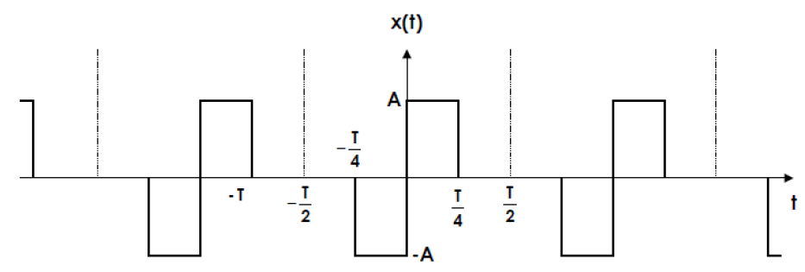

**Figure Q3(a):** Periodic signal

1. Knowing that the values of A = 1 and T = 4, put x(t) under the form:

$$x\left(t\right)=a_{0}+\sum_{n=1}^{n=4}{a_{n}}\cos\left(nω_{0}t\right)+b_{n}\sin\left(nω_{0}t\right)$$

where $ω_{0}=\frac{2π}{T}$

**[2 marks]**

1. The signal x(t) as described in b) is applied to a circuit whose transfer function is:

$$H\left(s\right)=\frac{Y(s)}{X(s)}=\frac{0.25s}{1+0.25s}$$

where X(s) and Y(s) are the Laplace transfer functions of the x(t) and the output y(t) of the circuit, respectively.

1. Determine the gain and the phase of the circuit.

**[3 marks]**

1. Find then the output of the circuit y(t). Explain and reflect on the results.

**[10 marks]**

**QUESTION 4 [25 marks]**

Consider the circuit describing a battery model and consisting of resistors and capacitors as shown in Figure Q4. The aim is to find the state-space model of the circuit, where the state space variables are the voltage v1(t) across the capacitor C1, and the voltage v2(t) across the capacitor C2, respectively. The output is represented by v0(t). The numerical values are: C1 = 200μF, C2 = 100μF, R1 = 2.5kΩ and R2 = 2kΩ.

Note that the general relationship that links the current to the voltage for a capacitor is given by: $C\frac{dv(t)}{dt}=i\left(t\right)$, where v(t) and i(t) are respectively, the voltage across the capacitor and the current flowing through it.



**Figure Q4**

1. Determine the differential equations for both the capacitor voltage, **v1(t),** and the capacitor voltage, **v2(t)**. Give the equation of the output voltage, **v0(t)**, in terms of the capacitor voltage, **v1(t)**. **[10 marks]**
2. Let’s rewrite the state variables v1(t) and v2(t) as x1(t) and x2(t), respectively. Let’s also rewrite the output voltage v0(t) and the input voltage as y(t) and u(t), respectively.
3. Using the state variables x1(t), x2(t) and the variables y(t) and u(t), write down the state equations and the output equation describing the circuit. **[3 marks]**
4. Express the equations in a matrix form:

**[5 marks]**

$$\dot{x}\left(t\right)=Ax\left(t\right)+Bu\left(t\right)$$

$$y\left(t\right)=Cx\left(t\right)+Du\left(t\right)$$

Where $x\left(t\right)$ is state vector and $\dot{x}\left(t\right)$ is the derivative of x(t) with respect to time.

1. Determine the Laplace transfer function from the state space representation.

**[7 marks]**

**End of Exam Paper**